DATA ANALYSIS AND ALGORITHMS
23CSE211

LAB-3

NAME: LOHITH BEJUGAM
R.NO: CH.SC.U4CSE24204
SEC: CSE-C

BFS:
CODE:
#include <stdio.h>

#define MAX 20

int graph[MAX][MAX];
int visited[MAX];
int queue[MAX];
int front = -1, rear = -1;
int n;

void enqueue(int x) {
if (rear == MAX - 1) return;
if (front == -1) front = 0;
queue[++rear] = x;
}

int dequeue() {
if (front == -1 || front > rear) return -1;
return queue[front++];
}

void bfs(int start) {
int i;
visited[start] = 1;
enqueue(start);

printf("\nBFS Traversal:\n");
while (front != -1 && front <= rear) {
int current = dequeue();
printf("%d ", current + 1);
for (i = 0; i < n; i++) {
if (graph[current][i] == 1 && !visited[i]) {
visited[i] = 1;
enqueue(i);
}
}
}
printf("\n");
}

void displayMatrix() {
int i, j;
printf("\nAdjacency Matrix:\n ");
for (i = 0; i < n; i++) {
printf("%d ", i + 1);
}
printf("\n ");
for (i = 0; i < n; i++) printf("--");
printf("\n");

for (i = 0; i < n; i++) {
printf("%d | ", i + 1);
for (j = 0; j < n; j++) {
printf("%d ", graph[i][j]);
}
printf("\n");
}
}

int main() {
int i, j, start, edge;

printf("Enter number of vertices: ");
scanf("%d", &n);

for (i = 0; i < n; i++)
for (j = 0; j < n; j++)
graph[i][j] = 0;

printf("\nEnter edges (1 for yes, 0 for no):\n");
for (i = 0; i < n; i++) {
for (j = i + 1; j < n; j++) {
printf("Is there an edge between %d and %d? ", i + 1, j + 1);
scanf("%d", &edge);
if (edge == 1) {
graph[i][j] = 1;
graph[j][i] = 1;
}
}
}

displayMatrix();

for (i = 0; i < n; i++)
visited[i] = 0;

printf("\nEnter starting vertex for BFS (1-%d): ", n);
scanf("%d", &start);

bfs(start - 1);

return 0;
}

OUTPUT:
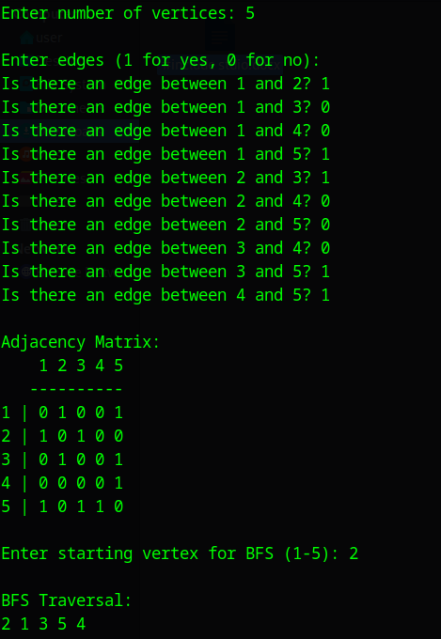

DFS:
CODE:
#include <stdio.h>

#define MAX 20

int graph[MAX][MAX];
int visited[MAX];
int n;

void dfs(int node) {
int i;
visited[node] = 1;
printf("%d ", node + 1);

for (i = 0; i < n; i++) {
if (graph[node][i] == 1 && !visited[i]) {
dfs(i);
}
}
}

void displayMatrix() {
int i, j;
printf("\nAdjacency Matrix:\n ");
for (i = 0; i < n; i++) printf("%d ", i + 1);
printf("\n ");
for (i = 0; i < n; i++) printf("--");
printf("\n");

for (i = 0; i < n; i++) {
printf("%d | ", i + 1);
for (j = 0; j < n; j++) {
printf("%d ", graph[i][j]);
}
printf("\n");
}
}

int main() {
int i, j, start, edge;

printf("Enter number of vertices: ");
scanf("%d", &n);

for (i = 0; i < n; i++)
for (j = 0; j < n; j++)
graph[i][j] = 0;

printf("\nEnter edges (1 for yes, 0 for no):\n");
for (i = 0; i < n; i++) {
for (j = i + 1; j < n; j++) {
printf("Is there an edge between %d and %d? ", i + 1, j + 1);
scanf("%d", &edge);
if (edge == 1) {
graph[i][j] = 1;
graph[j][i] = 1;
}
}
}

displayMatrix();

// Initialize visited array
for (i = 0; i < n; i++) visited[i] = 0;

printf("\nEnter starting vertex for DFS (1-%d): ", n);
scanf("%d", &start);

printf("\nDFS Traversal:\n");
dfs(start - 1);
printf("\n");

return 0;
}
OUTPUT:
